Technical Rider

for CONCERTS from 200 people
underlined = band's own equipment
Setup 1 – Jazz trio = POCKET JAZZ TRIO
(piano, double bass, drums)

PIANO:
Option 1: Grand piano
Grand piano tuned to A 442 Hz. Preferred Steinway D, B Yamaha CFIIIS, S6, C7 or equivalent.
Piano must be tuned before sound check.
The piano stool must be adjustable in height.
Space requirement: min. 7.00 x 3.00 m (for Steinway D, less for shorter pianos)
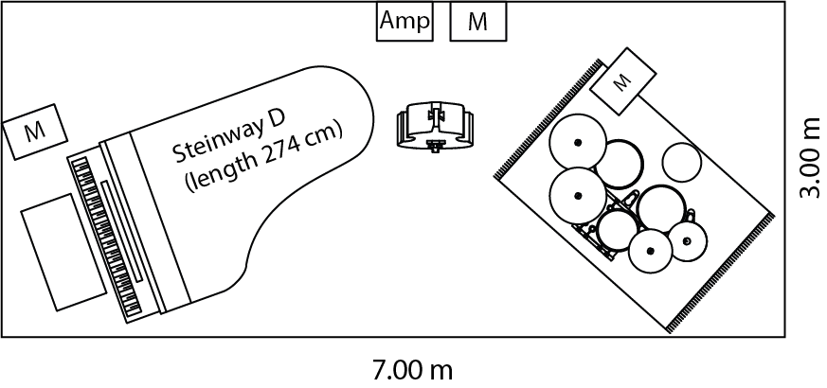
M = Monitor
Amp = Amplifier
Option 2: Upright piano
Well-maintained upright piano, preferably Yamaha U1 or equivalent.
Piano must be tuned before sound check.
The piano stool must be adjustable in height.
Space requirement: min. approx. 5.00 x 3.00 m

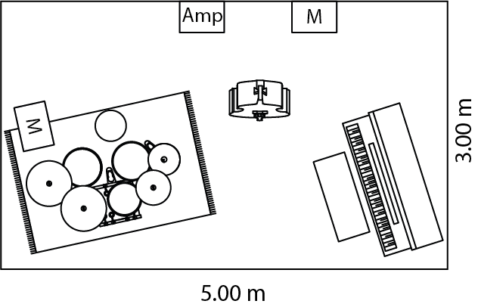

Option 3: Electric piano
As an exception, if no acoustic piano is available
Yamaha P-115 electric piano, including amplifier (Behringer Ultratone KXD12, 600 watts)
Space requirement: min. approx. 4.50 x 3.00 m
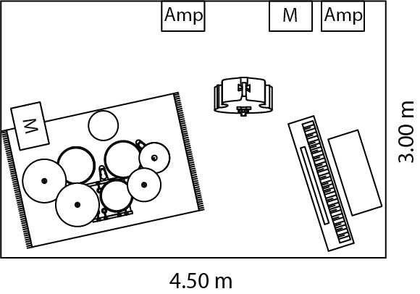

BASS:
Double bass (size 3/4)
Bass preamp: Gallien Krueger head or equivalent.
Bass amplifier: Gallien Krueger 1x10, Aguilar 2x10 or equivalent. Both wired.
DRUMS:
CANOPUS Neo Vintage NV60 M1 set (in possession and complete) or equivalent Jazz set:

Drum shell sizes
18 x 16“ bass drum, 14,5 x 5 1/2“ snare drum, 12“ tom, 14“ floor tom,

Hardware
1x snare drum stand, 3x cymbal stand, 1x hihat stand, 1x tom stand (bass drum gallows, not on floor), legs for floor tom, 1x bass drum pedal with soft felt beater (e.g. Schlagwerk BE 33 or Millenium Mesh Head Beater)

All shells with Remo coated Ambassador heads (on batter head and resonance head, except snare drum resonance head.... here clear, not coated)

Stool
TAMA 1st Chair HT750C Ergo Rider or equivalent.

own cymcals

Rug (size: min. 2.00 x 1.40 m) underneath the drum set
MICROPHONES:
Piano mics: 3 AKG C414 B ULS or equivalent + 1 stereo C-ducer for outdoor stages.
Bass mic: 1 Electrovoice RE 20 on double bass.
Drum mics: Bass drum: 1 RE 20 + snare: 1 SM57 + 2 overhead mics: SM81 or MKH-50
MONITORS:
3 monitors (for open-air concerts or large stages), otherwise 2 monitors (for piano and drums)
STAGE LAYOUT:
As compact as possible, as close to the audience as possible.

OTHER STAGE EQUIPMENT:
1 bottle of still water per instrument on stage
SOUND SYSTEM HALL:
The amps and monitors are for stage sound, not for sound reinforcement.
Only information about instruments and miking will be given. Please provide a sound system (PA) (with appropriate inputs for all microphones) including speakers according to the spatial situation in consultation with the sound engineer.
Appropriate sockets of the instruments amps, speakers are to be provided.

ARTIST DRESSING ROOM:
1 mirror
1 clothes rail with hangers
1 bottle of still water per musician
Space for temporary storage of instrument cases
Setup 2 – Jazz trio + guest musicians (POCKET JAZZ TRIO & friends)
(piano, double bass, drums + guest musicians)

PIANO:
Option 1: Grand piano
Grand piano tuned to A 442 Hz. Preferred Steinway D, B Yamaha CFIIIS, S6, C7 or equivalent.
Piano must be tuned before sound check.
The piano stool must be adjustable in height.
Space requirement: min. 7.00 x 3.50 m (for Steinway D, less for shorter pianos)
(with 1-2 guest musicians)

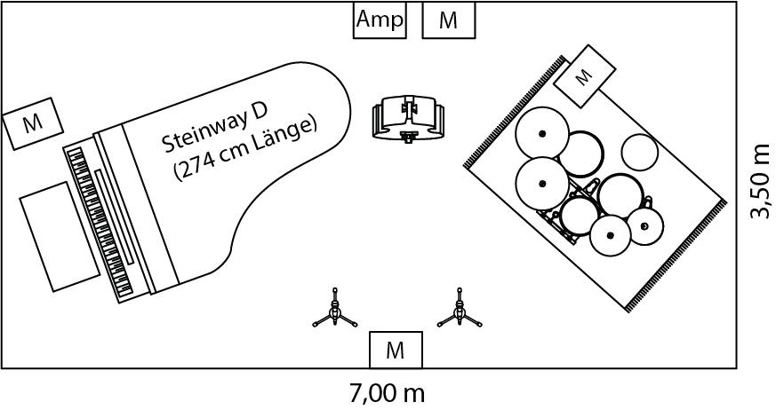

M = Monitor
Amp = Amplifier
Option 2: Upright piano
Well-maintained upright piano, preferably Yamaha U1 or equivalent.
Piano must be tuned before sound check.
The piano stool must be adjustable in height.
Space requirement: min. approx. 5.50 x 4.00 m
(with 1-2 guest musicians)

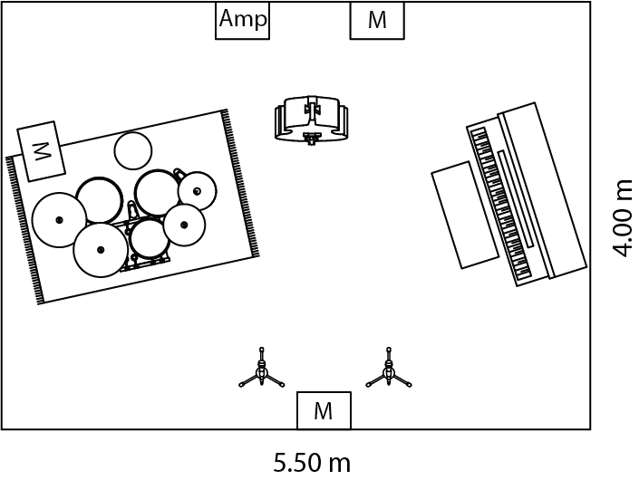

Option 3: Electric piano
As an exception, if no acoustic piano is available
Yamaha P-115 electric piano, including amplifier (Behringer Ultratone KXD12, 600 watts)
Space requirement: min. approx. 5.00 x 4.00 m
(with 1-2 guest musicians)

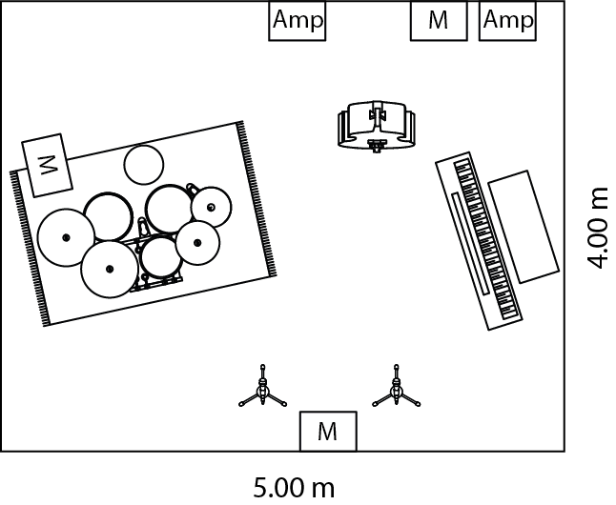

BASS:
Double bass (size 3/4)
Bass preamp: Gallien Krueger head or equivalent.
Bass amplifier: Gallien Krueger 1x10, Aguilar 2x10 or equivalent. Both wired.
DRUMS:
CANOPUS Neo Vintage NV60 M1 set (in possession and complete) or equivalent Jazz set:

Drum shell sizes
18 x 16“ bass drum, 14,5 x 5 1/2“ snare drum, 12“ tom, 14“ floor tom,

Hardware
1x snare drum stand, 3x cymbal stand, 1x hihat stand, 1x tom stand (bass drum gallows, not on floor), legs for floor tom, 1x bass drum pedal with soft felt beater (e.g. Schlagwerk BE 33 or Millenium Mesh Head Beater)

All shells with Remo coated Ambassador heads (on batter head and resonance head, except snare drum resonance head.... here clear, not coated)

Stool
TAMA 1st Chair HT750C Ergo Rider or equivalent.

own cymcals

Rug (size: min. 2.00 x 1.40 m) underneath the drum set
GUEST MUSICIANS:
typically vocals, trumpet, saxophone or guitar
bring their own instruments, consult with guest musicians for special equipment on a case-by-case basis (e.g. amps)
MICROPHONES:
Piano mics: 3 AKG C414 B ULS or equivalent + 1 stereo C-ducer for outdoor stages.
Bass mic: 1 Electrovoice RE 20 on double bass.
Drum mics: Bass drum: 1 RE 20 + snare: 1 SM57 + 2 overhead mics: SM81 or MKH-50
additionally guest musicians:
1. for vocals: own microphone with phantom power, microphone stand (height-adjustable), please provide XLR-cable
2. for trumpet / saxophone / trombone: 1 dynamic microphone per wind player (e.g. SHURE SM57, SM58 or equivalent), 1 microphone stand each (height adjustable)
MONITORS:
4 monitors (for open-air concerts or large stages), otherwise 3 monitors (for piano, drums and guest musicians)

STAGE LAYOUT:
As compact as possible, as close to the audience as possible.

OTHER STAGE EQUIPMENT:
1 bottle of still water per instrument on stage
SOUND SYSTEM HALL:
The amps and monitors are for stage sound, not for sound reinforcement.
Only information about instruments and miking will be given. Please provide a sound system (PA) (with appropriate inputs for all microphones) including speakers according to the spatial situation in consultation with the sound engineer.
Appropriate sockets of the instruments amps, speakers are to be provided.

ARTIST DRESSING ROOM:
1 mirror
1 clothes rail with hangers
1 bottle of still water per musician
Space for temporary storage of instrument cases

Setup 3 – „Pocket“-Setup + optional guest musician (POCKET JAZZ TRIO & friends)
(electric piano/melodica, double bass, snare drum/hihat + 1 guest musician)

for CONCERTS between 15 - 50 people
For constricted spaces, living room concerts, restaurants, etc.

OPTION 1: electric piano + melodica, double bass, minimal drums (snare drum + hihat)

PIANO:
Yamaha P-115 electric piano, including amplifier (Behringer Ultratone KXD12, 600 watts)
Space requirement: min. approx. 3.00 x 3.00 m

setup variant 1 setup variant 2

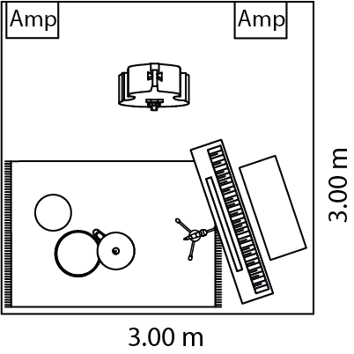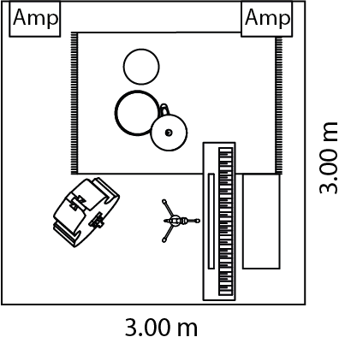

Amp = Amplifier

MELODICA:
own melodica or Hohner Performa Melodica 27 or equivalent.
With tube

BASS:
Double bass (size 3/4)
Bass preamp: Gallien Krueger head or equivalent.
Bass amp: Fender Rumble 115 Cabinet V3 or equivalent. Both wired.

DRUMS:
Parts of a CANOPUS Neo Vintage NV60 M1 set (owned) or equivalent Jazz set:

14,5 x 5 1/2" snare drum with Remo coated Ambassador head (batter head) and clear resonance head (instead of coated)

Hardware
1x snare drum stand, 1x hihat stand

Stool
TAMA 1st Chair HT750C Ergo Rider or equivalent.

own cymcals

Rug (size: min. 2.00 x 1.40 m) underneath the drum set

MICROPHONES:
Melodica: 1 dynamic microphone (e.g. SHURE SM57, SM58 or equivalent) with cable (XLR) and stand (height adjustable) on electric piano

MONITORS:
No monitors required

STAGE LAYOUT:
Constricted space conditions depending on the venue, therefore flexible layouts possible

OTHER STAGE EQUIPMENT:
1 bottle of still water per instrument on stage

SOUND SYSTEM ROOM:
No room sound system necessary, amps and stage sound are enough.
Double bass can play acoustically.

STORAGE ROOM:
Space for temporary storage of the instrument bags

OPTION 2: Electric piano + melodica, double bass, minimal drums (snare drum + hihat),
1 guest musician
Space requirement: min. approx. 3.50 x 3.50 m

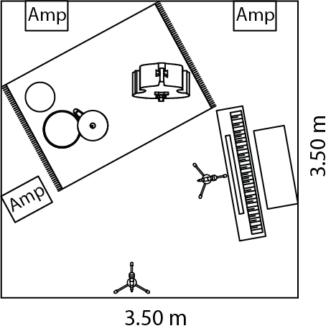

as OPTION 1, but additional musician(s) and space required

GUEST MUSICIANS:
typically vocals, trumpet, saxophone or guitar
bring their own instruments, consult with guest musicians for special equipment on a case-by-case basis (e.g. amps)

MICROPHONES:
additionally guest musicians:
1. for vocals: own microphone with phantom power, microphone stand (height-adjustable), please provide XLR-cable
2. for trumpet / saxophone / trombone: 1 dynamic microphone per wind player (e.g. SHURE SM57, SM58 or equivalent), 1 microphone stand each (height adjustable)
SOUND SYSTEM ROOM:
No room sound system necessary, amps and stage sound are enough.
Double bass can play acoustically.

